Annex E- GEF Data Sheet – Vulnerability context and LDCF additional Reasoning
- Description and context for Intervention sites

- Risk and Vulnerability Profiles of Selected Communities Supported by the AF.
- Sao Tome and Principe has typical characteristics of small island developing stares with high social vulnerabilities mainly due to high poverty rates, small economies sensitive to external economic shocks and highly depend on foreign aid. STP is also exposed to multi-hazards: floods, droughts, coastal erosion, storm surges, and sea level rise. Climate change is exacerbating weather related events. Modeled projections for various scenarios indicate and increase of the extremes for precipitations and droughts for the low- and high-emission scenarios (RCP 4.5 and RCP 8.5 respectively). Temperatures will increase between 2 and 3 degree Celsius for the RCP 4.5 scenario and up to 5 degrees for the RCP 8.5 scenario. Average sea level rise is predicted to increase up to 0.74 cm by the end of the century. Coastal erosion has already caused beaches retreat and sea level rise will increase erosion rates. In this context, extreme and chronic events, mainly revering and coastal flooding and coastal erosion, will severely impact already vulnerable populations.
- The number of people below the poverty line has grown consistently between 1984 and 2001: from 36% of the total population in 1984 to almost 54% in 2001 (Monteiro Fortes, 2011) and 66% in 2009 (CIA World Fact Book). The poverty is unequally distributed, meaning that in some parts of the country the number of people below the poverty line is much more than 66%. Knowing and understanding the local poverty situation is essential when looking into local problems and solutions related to extreme meteorological events and climate change. Unemployment is difficult to measure and probably runs at about 50% (Becker 2008).
- Most vulnerable communities are located along the coast. Some communities, such as Santa Catarina, Praia Cruz, Gambôa, Lochinga, Pantufo e Praia Melao have features more characteristics to urban locations with bigger populations and a more diversified economic activities, with a share of the population working in the capital of Sao Tome. The other communities are more rural in nature, with higher poverty levels and with livelihoods depending mainly on fishery activities, which makes them more vulnerable to the impacts of climate change.
- Table 1 provides some basic population statistics for some of the communities.

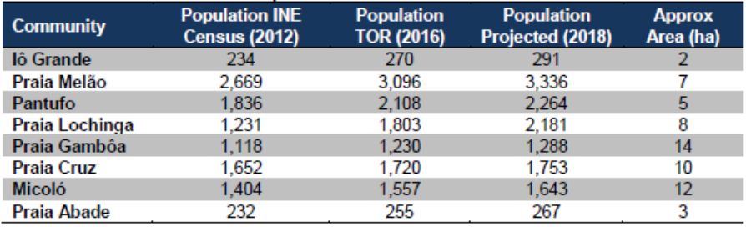
Table 1: Population of some communities for year 2012, population according to the project terms of reference (year 2012), and projected population for year 2018 based on the 2012 and 2016 data. In the last column, the estimated extension of each community is shown.
- To select the communities of the project, a participatory approach has been undertaken combined with information from past events and available risk maps. The selected communities are the ones with higher levels of exposure to floods and with the most vulnerable communities. The AF would allow to expand the support from eight communities to 12 through construction of small to medium flood protection structures including green infrastructure.

- The section below describes more in detail the characteristics of some communities and their risk profile. The case of Io Grande presents a more detail description than the others showing a summary of information available for all communities. For more details for the other communities refer to the study of Deltares, 2019.

- Iô Grande
Site description and aerial view
- Iô Grande is a small village in the southeast corner of São Tomé Island, in the Caué District. Photo 1 depicts the waterfront area at this small site. Figure 2 zooms in and marks important facilities and infrastructure, areas particularly susceptible to natural hazards, and areas of ecological and cultural importance.
- The village is only accessible from the N2 main road, running north-south, followed by an unpaved road. Characteristic features in the village are the primary school near the beach. There are three permanent small kiosks where the community can buy daily household essentials, one healthcare center providing basic attention and first aid, and a small catholic church.
- The population is estimated at 291 people in 2018. This agrees with the estimate provided by the leader of the community (280).
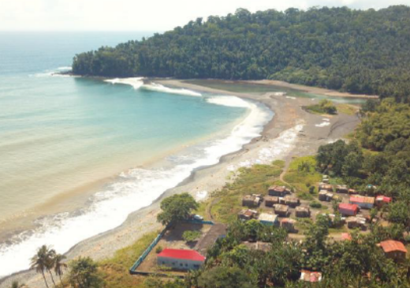 | 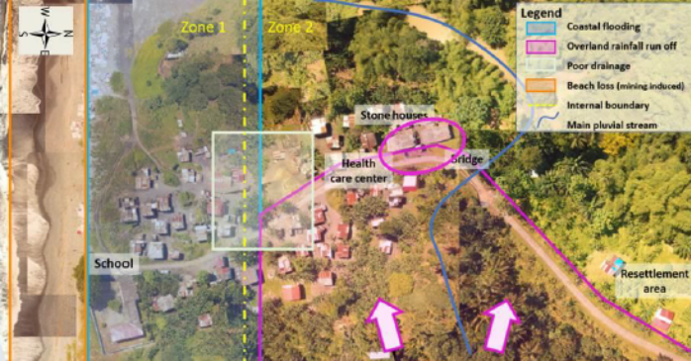
Photo 1 Aerial view of Iô Grande, facing southwest. The community also continues inland, to the right of the photo. Drone image by J. Pronker, CDR International. | Figure 2 Site Map: Iô Grande

- Photo 2 shows the typical houses in Io Grande. In general, all houses have minimum 40 - 50 cm of elevation in poles.

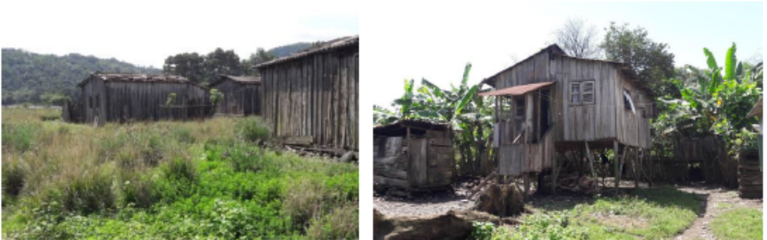
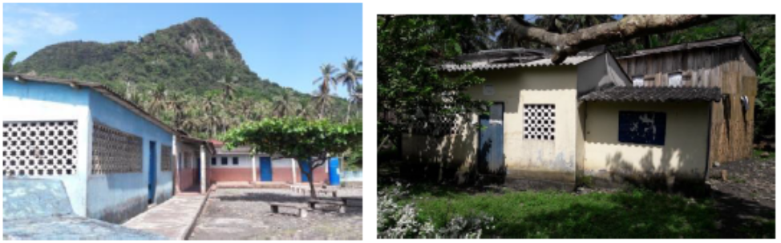
Photo 2: (Above left) Typical ground-level houses near the coast and (Above right) raised wooden houses further inland, in Iô Grande. Photos by B. Ottow. (Below left) primary school and (below right) health care center in Iô Grande. Photos by B. Ottow.

Hazards description
Flooding
- The flood maps in Figure 3 show that the estimated flood depth and extent increases along the small river in the western part of the community. In addition, the southwestern corner experiences an increase in water depth, while the southern part of the community experiences more widespread flooding.
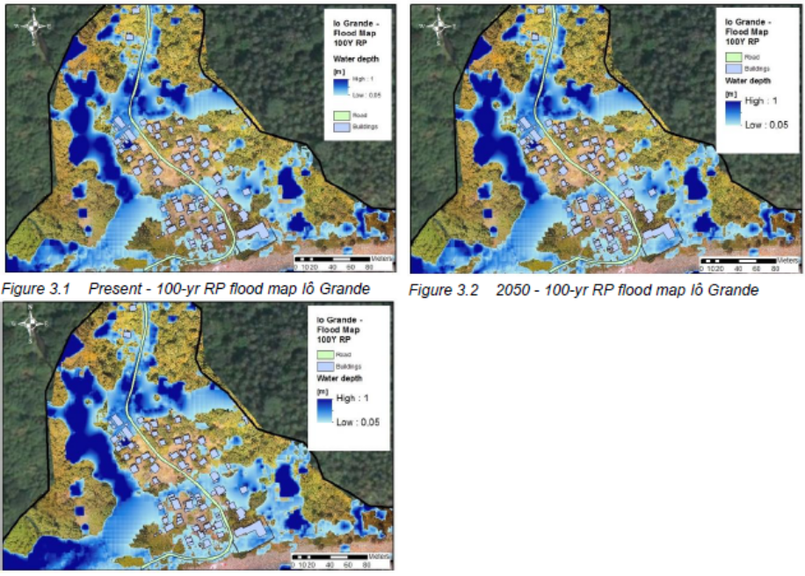
Figure 3: (Above left) Present - 100-yr RP flood map Iô Grande, (above right) 2050 - 100-yr RP flood map Iô Grande, (below left) 2100 - 100 yr RP flood map for Iô Grande.

- Figure 4 shows the risk (Estimated Annual Average Losses - EAAL) per household, per time horizon (present, 2050 and 2100) for Iô Grande, as well as an estimate of the total risk from flooding for the all community. Risks are defined as losses (in STD) per year per household, within different areas characterized by similar hazards (e.g. coastal flooding/rainfall) and/or separated by specific features (e.g. the presence of a road). In the figure direct damages only are shown.
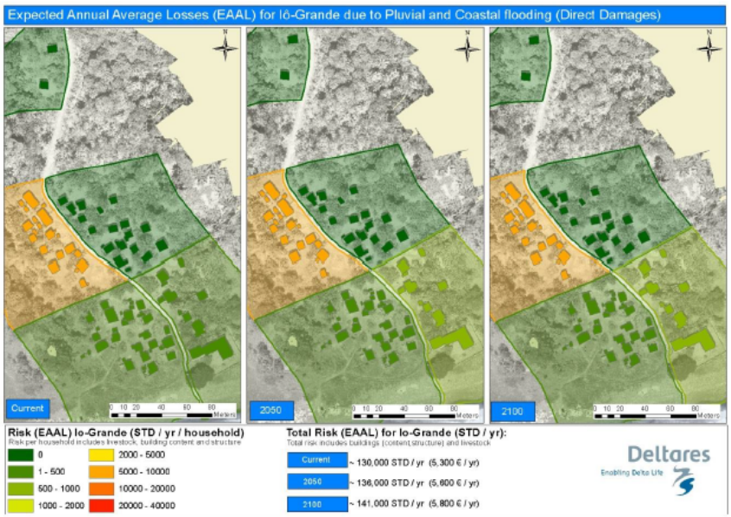
Figure 4: Total EAAL and EAAL per household in Iô Grande, due to direct economic damages only, from pluvial and coastal flooding. The community was divided into 5 regions, using the access road as a dividing line. Risk is computed in 2018 STD and does not take into account socio-economic changes over time.

Combined coastal erosion and flood risk, including socio-economic changes
- Table 2 show the total combined risk in Iô Grande due to coastal flooding, pluvial flooding and coastal erosion, including climate change and socio-economic growth. Damages are expected to increase with both climate change (increase in hazard) and socioeconomic growth (increase in vulnerability) independently, but especially when both occur simultaneously.
- The increase in damages from the present situation to the 2100 situation is of about a factor four when only changes in hazard are considered (scenario 1). When only socio-economic growth is considered, the increase is of a factor 12 (scenario 2), and when both factors are taken into account (socio-economics and climate change) the factor can be up to 50 times.
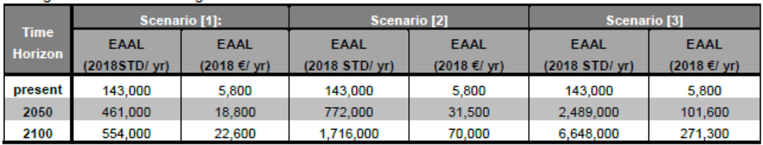
Table 2: Expected annual average losses (EAAL) due to erosion and flooding (coastal and pluvial) in Iô Grande in the present situation, 2050, and 2100, accounting for different scenarios: [1] Risks including change in hazards due to climate change but excluding socio-economic growth, [2]: Risk including socio-economic growth but excluding change in hazards due to climate change and [3]: Risk including both change in hazards due to climate change and socio-economic growth
- Praia Melão
Site description and aerial view
- Praia Melão is located south of the communities of Ghanda and Pantufo and is part of the district of Mé-Zóchi. The village is located in the northeast corner of São Tomé Island, 4.5 km south of the capital. Characteristic features of the village are the football field, the association of fishermen, and the church in the southern part of the village. Photo 3 show aerial views of the community and Figure 5 is a site map, which marks important facilities and infrastructure, areas particularly susceptible to natural hazards, and areas of ecological or cultural importance.
- Praia Melão is located along the secondary road EE103 (INAE). Praia Melão is the most populous of the 12 project sites, with approximately 3096 residents in 2016. With an estimated average annual growth rate of 8% the population in 2018 correspond to a population estimated at 3336. According to women living in the area, woman have 4 to 8 children, so families have approximately 6-10 members who normally live together in the same house (see Photo 4).
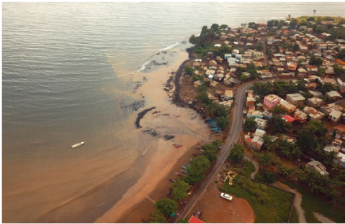 | 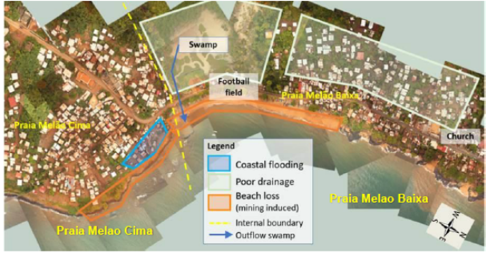
Photo 3: Aerial view of Praia Melão, facing southeast. Drone image by J. Pronker, CDR International. | Figure 5: Site Map: Praia Melão

Hazards description
Combined coastal erosion and flood risk, including socio-economic changes
Table 4 show the total combined risk to Praia Melão due to coastal flooding, pluvial flooding and coastal erosion, including climate change and socio-economic growth. Damages are expected to increase with both climate change (increase in hazard) and socio-economic growth (increase in vulnerability) independently, but especially when both occur simultaneously.
- The increase in damages from the present situation to the 2100 situation is of about a factor 2.5 when only changes in hazard are analyzed (scenario 1). When only socio-economic growth is considered, the increase in risk is a factor 12 (scenario 2), and when both factors are taken into account (socio-economics and climate change) the factor can be up to 28 times.
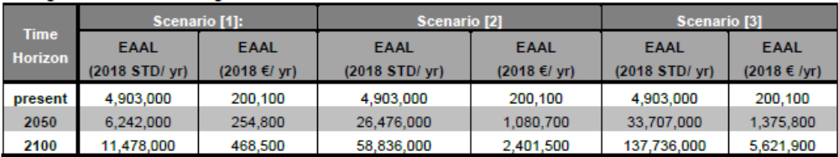
Table 4 Expected annual average losses (EAAL) due to erosion and flooding (coastal and pluvial) in Praia Melao in the present situation, 2050, and 2100, accounting for different scenarios: [1] Risks including change in hazards due to climate change but excluding socio-economic growth, [2]: Risk including socio-economic growth but excluding change in hazards due to climate change and [3]: Risk including both change in hazards due to climate change and socio-economic growth
- Pantufo
Site description and aerial view
- Pantufo is located just south of the city of São Tomé, in Água Grande District, on the northeast coast of São Tomé Island. Photo 5 show an aerial view of Pantufo, facing north while Figure 6 is a site map, which marks important facilities and infrastructure, areas particularly susceptible to hazards, and areas of ecological and cultural importance. The population of the village is estimate to be of 2264 residents in 2018.
- Pantufo is located along the secondary road EE103 (INAE). This road runs parallel to the beach and reconnects with NE2 further to the south. The town is defined by a large square in front of the Catholic church. The town school is located further south, on the landward side of the road, at the border with Praia Melão (outside the borders of the site map).
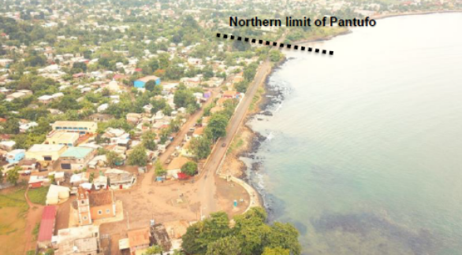 | 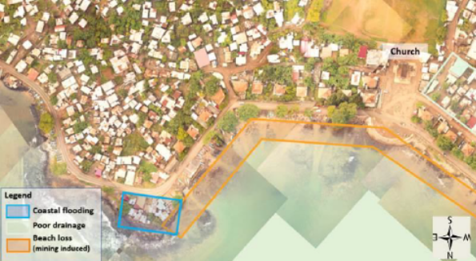
Photo 4: Aerial view of Pantufo, facing north. Drone image by J. Pronker, CDR International. | Figure 6: Site Map: Pantufo

Hazards description
Combined coastal erosion and flood risk, including socio-economic changes
- Table 5 show the total combined risk to Pantufo due to coastal flooding, pluvial flooding and coastal erosion, including climate change and socio-economic growth. Damages are expected to increase with both climate change (increase in hazard) and socioeconomic growth (increase in vulnerability) independently, but especially when both occur simultaneously.
- The increase in risk from the present situation to the 2100 situation is of about a factor 3.5 when only changes in hazard are analyzed (scenario 1). When only socio-economic growth is considered, the increase in risk is a factor 12 (scenario 2), and when both factors are taken into account (socio-economics and climate change) the factor can be up to 40 times.

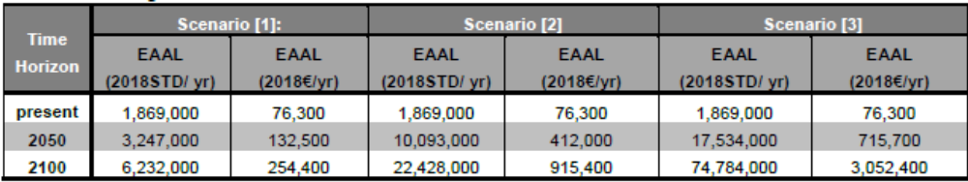
Table 5: Expected annual average losses (EAAL) due to erosion and flooding (coastal and pluvial) in Pantufo in the present situation, 2050, and 2100, accounting for different scenarios: [1] Risks including change in hazards due to climate change but excluding socio-economic growth, [2]: Risk including socio-economic growth but excluding change in hazards due to climate change and [3]: Risk including both change in hazards due to climate change and socio-economic growth
- Praia Lochinga, Gamboa, and Cruz
Site description and aerial view
- Praia Cruz, Gambôa and Lochinga are three adjacent coastal communities between the São Tomé International Airport and the north coast, in Água Grande District. Photo 5 shows two views of the beach. Figure 7 is a site map, which marks important facilities and infrastructure, areas particularly susceptible to natural hazards, and areas of ecological and cultural importance.
- The estimated population in 2018 for all three communities is 5222. The population is skewed young, with women having on average 5 to 8 children, starting at age 15.
- Praia Lochinga (sometimes spelled Loxinga) is the easternmost community, densely developed in the narrow strip of land (~100 m) between the São Tomé International Airport and the sea. There is only one access road (same to access the airport), which ends in Lochinga. Most of the housing is between the road and the sea, while some houses were constructed between the airport wall and the road.
- Praia Gambôa is the community between Praia Cruz and Praia Lochinga. The strip of houses between the main road and the airport is much broader at Praia Gambôa than in Lochinga. At the border between Lochinga and Gambôa, there is a stagnant pond, with an adjacent functioning laundry facility. On the other side of the road are the Pentecostal and Adventist churches. The latter is mainly frequented by people from Lochinga. In the center of Gambôa is a catholic church. Most of the fish from all three communities arrives at Praia Gambôa. The fish market “SãoPaulo” is located next to the beach where the fishermen return with their catch. The fishermen association is located along the main road.
- Praia Cruz is the westernmost of the three communities. The most conspicuous element is the large football field at the west side of the village (Figure 4.8). Further south is the primary school for all 651 children in the three communities (and Diogo Nunes). All the children (100%) attend school, in two shifts each day. Next to the school is the health centre, which serves all four communities. Praia Cruz has its own beach, which is much steeper than the one at Gambôa. At the west end of the community there is a large pond that a Chinese project attempted to use for fish breeding.
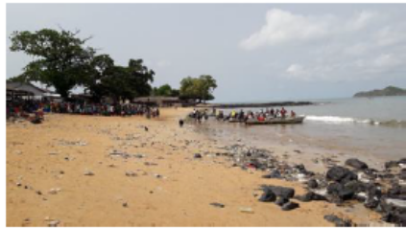  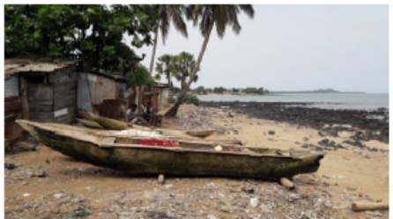 | 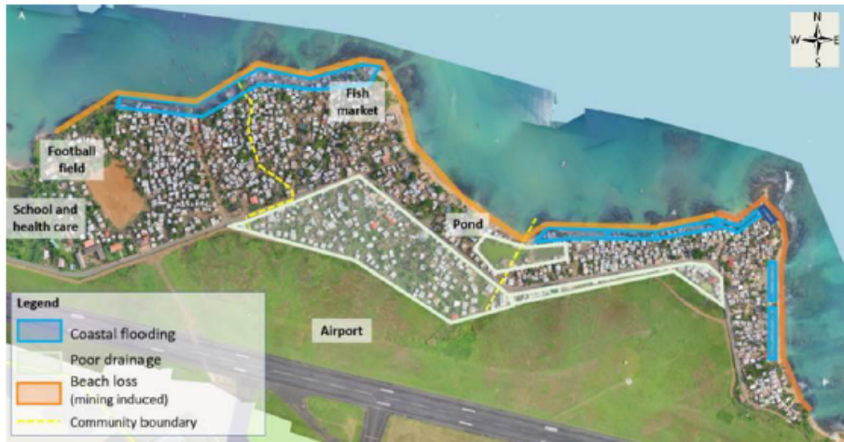
Photo 5: The beaches of Lochinga (top) and Gambôa (low). | Figure 7: Site Map of Praia Cruz, Gambôa, and Lochinga, with drone image courtesy of CONPREC, OLA, and SNPCB (2018).

Hazards description
Combined coastal erosion and flood risk, including socio-economic changes
- Table 6 show the total combined risk to the Airport region due to coastal flooding, pluvial flooding and coastal erosion, including climate change and socio-economic growth. Damages are expected to increase with both climate change (increase in hazard) and socio-economic growth (increase in vulnerability) independently, but especially when both occur simultaneously.
- The increase in damages from the present situation to the 2100 situation is of about a factor 2 when only changes in hazard are analyzed (scenario 1). When only socio-economic growth is considered, the increase in risk is a factor 12 (scenario 2), and when both factors are taken into account (socio-economics and climate change) the factor can be up to 26 times.
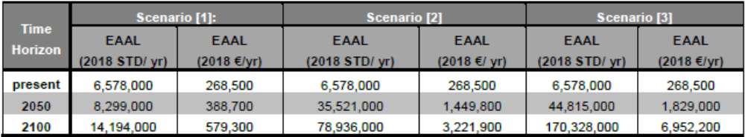
Table 6: Expected annual average losses due to erosion and flooding (coastal and pluvial) in the Airport region in the present situation, 2050, and 2100, accounting for different scenarios: [1] Risks including change in hazards due to climate change but excluding socio-economic growth, [2]: Risk including socio-economic growth but excluding change in hazards due to climate change and [3]: Risk including both change in hazards due to climate change and socio-economic growth.

- Micoló
Site description and aerial view
- Micoló is a town on the north coast of São Tomé Island, in the Lobata District. Photo 6 show two aerial views of the community. Figure 8 is a site map which marks important facilities and infrastructure, areas particularly susceptible to natural hazards, and areas of ecological and cultural importance.

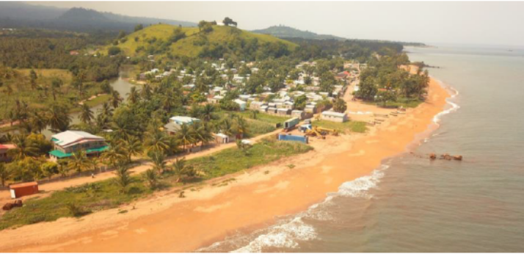
Photo 6: Aerial view of Micoló, facing west. Drone image by J. Pronker, CDR International.
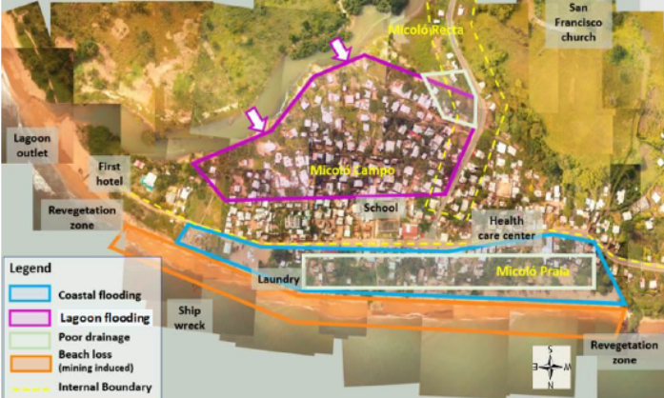
Figure 8: Site Map: Micoló

- In 2012, the population of Micoló was 1404 people plus 431 people living in the area of Micoló Recta (INE, 2012). The estimated population for 2018 is of more than 2000. Households have between 4 and 10 members. Women normally start having children around the age of 16. The general perception of the population establishes that there are more women than men (60% women and 40% men).
Hazards description
- Table 7 show the total combined risk to Micoló due to coastal flooding, pluvial flooding and coastal erosion, including climate change and socio-economic growth. Damages are expected to increase with both climate change (increase in hazard) and socioeconomic growth (increase in vulnerability) independently, but especially when both occur simultaneously.
- The increase in damages from the present situation to the 2100 situation is of about a factor four when only changes in hazard are analysed (scenario 1). When only socio-economic growth is considered, the increase in risk is a factor 12 (scenario 2), and when both factors are taken into account (socio-economics and climate change) the factor can be up to 50 times.

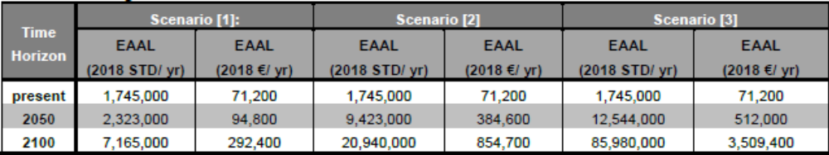
Table 7: Expected annual average losses due to erosion and flooding (coastal and pluvial) in Micoló in the present situation, 2050, and 2100, accounting for different scenarios: [1] Risks including change in hazards due to climate change but excluding socio-economic growth, [2]: Risk including socio-economic growth but excluding change in hazards due to climate change and [3]: Risk including both change in hazards due to climate change and socio-economic growth

- Praia Abade
Site description and aerial view
- Praia Abade is located in the Autonomous Region of Príncipe on the east side of the island, 7 km from the capital, in a small pocket beach in a very sheltered cove. Photo 7 captures the coastline of the community. Figure 9 is a site map, which marks important facilities and infrastructure, areas particularly susceptible to natural hazards, and areas of ecological and cultural importance.
- The community has only one dirt access road, which is currently undergoing upgrades. There are few houses between the beach and the road. The majority of the population lives on the landward side of the road (including the health care center, kindergarten, and school).
- Population estimates indicate approximately 268 residents in 2018. In this region, households have 6 to 10 members. The general perception of the population establishes that there are more men than women (60% men and 40% women).

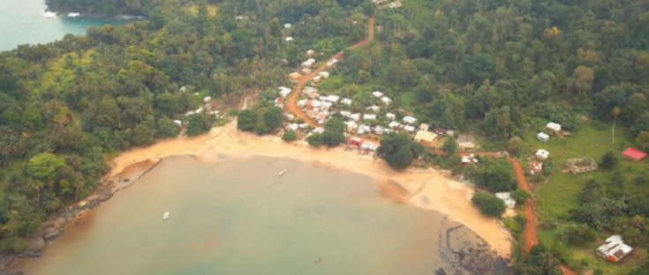 | 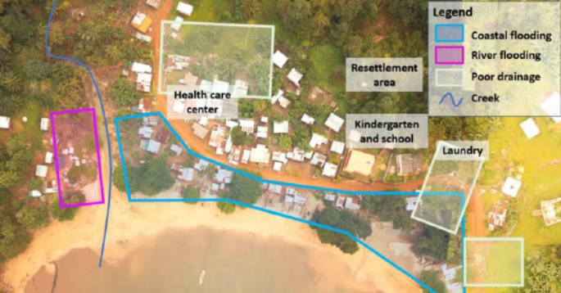
Photo 7: Aerial view of Praia Abade, facing east. Drone image by J. Pronker, CDR International. | Figure 9: Site Map: Praia Abade

Hazards description
- Table 8 show the total combined risk to Praia Abade due to coastal flooding, pluvial flooding and coastal erosion, including climate change and socio-economic growth. Damages are expected to increase with both climate change (increase in hazard) and socio-economic growth (increase in vulnerability) independently, but especially when both occur simultaneously.
- The increase in damages from the present situation to the 2100 situation is of about a factor 2 when only changes in hazard are analyzed (scenario 1). When only socio-economic growth is considered, the increase in risk is a factor 12 (scenario 2), and when both factors are taken into account (socio-economics and climate change) the factor can be up to 24 times.

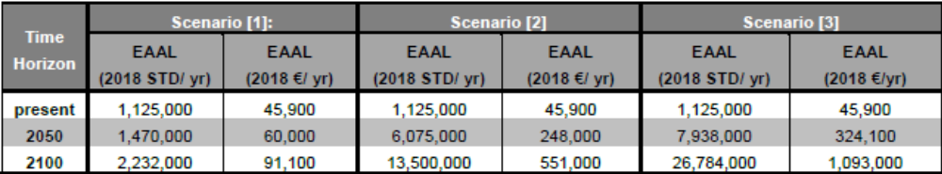
Table 8: Expected annual average losses due to erosion and flooding (coastal and pluvial) in Praia Abade in the present situation, 2050, and 2100, accounting for different scenarios: [1] Risks including change in hazards due to climate change but excluding socio-economic growth, [2]: Risk including socio-economic growth but excluding change in hazards due to climate change and [3]: Risk including both change in hazards due to climate change and socio-economic growth

- Map Location of communities supported by the WACA ResIP including the AF
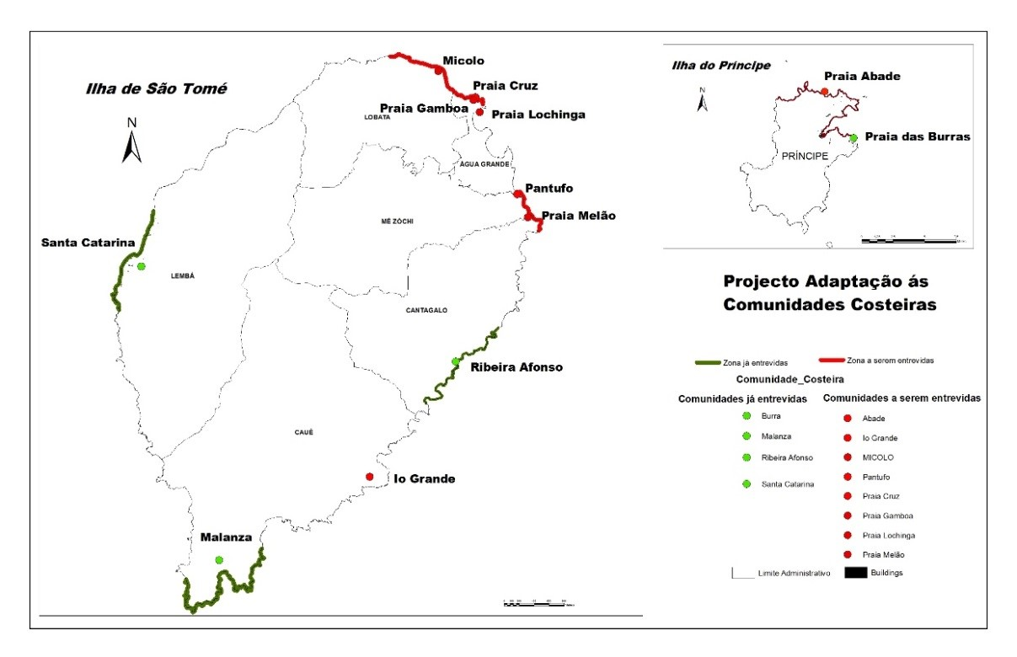

- LDCF Additional Reasoning

- During the preparation of the Parent Project, WACA-ResIP, a set of activities were identified for a total budget of US$ 15.15 million. While US$8.0 million were available from IDA and US$ 1.15 million from the International Water Window of the GEF, a US$ 6.0 million proposal was submitted to the GEF secretariat to finance, from the Least Developed Countries fund (LDCF) the activities proposed under this Additional Financing (AF). This AF aims to scale-up the development impact of the parent project in São Tomé and Príncipe by implementing activities embedded and envisaged in the planning phase of the Parent Project, but not yet financed.
- The Parent project, WACA ResIP, emphasizes the development of safer relocation areas to provide incentives for the population not to settle in the most at-risk areas, but additional investments are needed to restore the natural ecosystems so that they could play their original role of adaptative protection from tides, surges and sea-level-rise; and to develop them to promote community-based sustainable income generating activities, such as tourism and sustainable fisheries.
- As designed, activities under this AF will scale-up risk mitigation and adaptation measures from eight to 12 of the most vulnerable communities following the Parent Project participatory approach. Activities under the AF will complement planned relocation with scaled-up risk mitigation measures and ensure that the to-be vacated areas are properly planned to ensure their long-term sustainability and avoid future re-settlements in these as risk areas. The process of helping the pilot communities expand into safer areas may be shortchanged if the to-be voluntary vacated areas would not be restored and properly planned and used for sustainable and resilient uses. Also, additional adaptation measures will be needed to protect the rest of the communities, to the threat of climate change, through improvement of the drainage system.
- The AF would also help to improve the early warning and safety at sea amongst artisanal fishers, and thus ensure that lives can continue to be saved over the long term. Principles of safety at sea would have been introduced amongst part of the coastal fishermen - with an immediate observable impact - but with uncertain sustainability due to the time required to change risk behavior. The AF will also expand the outreach of the safety at sea program from 1750 to now 4,155 artisanal fishers (all identified artisanal fishermen in the country) and improve the early warning system component of the project by complementing the weather forecast with two additional marine meteorological stations.
- Given that such activities represent a natural complement to the parent Project WACA-ResIP activities, AF seems the most appropriate option to maximize development outcomes. The project will enable a faster and more cost-effective response to the client’s request to sustain and scale-up the results. The responsible agency, Directorate General of Environment, Ministry of infrastructure, Public Work, Natural Resource and Environment, has demonstrated its strong commitment, and has proved to be a competent counterpart agency, as shown by the initial project’s satisfactory track records. There would be no change to the key implementation arrangements put in place.
- The AF would contribute to Climate Change Adaptation (CCA) objectives “Reduce vulnerability and increase resilience through innovation and technology transfer for climate change adaptation” (CCA-1) of the GEF/LDCF Focal Areas. The AF would serve as a pilot case for the implementation of solutions tailored to the needs and the contexts of the Small Islands States, to adapt to climate change and build resilience to disaster risk in their coastal areas.
- The AF addresses the top three priorities of the NAPA (Training and equipment for artisanal fishermen, Early warning climate alert system, and Communication action for behavior change), as well as Priorities 9 (Relocation of coastal communities at risk of floods and landfalls) and 10 (Construction of shelters for artisanal fishermen).
- The AF also addresses three of the five short-to-medium term adaptation actions identified by the NDC, namely action II, “Reduce the number of people living in vulnerable areas at risk, by providing housing in safer areas”, action IV, “Introduce radar reflectors on board all fishing vessels by 2025, reducing the number of accidents at sea” and action V, “Train and equip fishermen with means to enable safe fishing” (…)..
- The AF is also fully consistent with STPs National Development Plan (2017-21), which emphasizes mainstreaming of climate change issues in the countries’ policies as a key strategic action and specifically calls for the “rehabilitation of settlement exposed to risks of climate change (5.2.3.3.5)”, the “improvement of the network for meteorological observation, forecast and warning, as well as the dissemination system (5.5.1.3)” and “reduction of climate impacts on population, especially for the coastal communities at risk (5.5.1.5)”.

- Project Baseline and Coordination with Other Activities

- While the AF will be processed linked to the baseline WACA project, it will leverage new and additional co- financing as detailed. A substantial part of the co-financing (estimated at US$200,000 per district, or a total of US$1.4 million) is the expected in-kind counterpart contribution from the seven participating districts, to fund maintenance activities in the target communities and social developments in the expansion areas. Evidence from the first project indicates that this is already happening – in Malanza, for example, the Government installed electricity in the expansion area and is planning the construction of a new school. In addition, São Tomé and Príncipe has established community-based risk management committees in the targeted villages, whose role is to organize maintenance activities, as well as encourage adaptation and risk reduction. The expected end result is that all districts in São Tomé and Príncipe will have gained experience from incorporation of adaptation and risk‐based management into participatory local development plans, and that the model can then mainstreamed nationwide.
- Also, in Agua Grande District, an infrastructure project, jointly financed the Dutch cooperation program DRIVE and the European Investment Bank, will build coastal protection works (sea wall, rock revetment and beach nourishment) for an estimated amount around US$6 million, between the proposed project intervention sites from Praia Gamboa (airport) to Pantufo. These activities provide geographical complementarity and contiguity in the measures taken for coastal protection and strengthening to link the rural and urban coastal segments. LDCF support will cover the green infrastructure elements in synergy with the IDA supported grey infrastructure investments. The project is also implemented by the DG Environment; therefore coordination will be ensured both at project implementation and at technical level.
- Also, the government of São Tomé and Príncipe, with support from IDA, is implementing a project to develop the transport sector, with a special focus on strengthening its resilience to climate change and protecting the transport from coastal risk. The project will train staff of the national Institute for road, as well as the community-led maintenance groups (“GIMEs”), to monitor and implement, coastal protections, using locally available material and equipment. The project will pilot small scale interventions, for a total co-contribution of 1.0 million (technical assistance and small works).
- The WACA project has been prepared under the NDC Partnership framework, a group of donors and international partners led by World Research Institute and coordinated with the national institutions in the country by UNDP. This partnership aims to support the coherent and integrated implementation of the country’s climate change adaptation framework in general and the NDC in particular. Through this collaboration, a list of on-going and under-preparation projects, as well as gaps to ensure proper coordination and avoid overlaps. The WACA project (Parent Project and the GEF proposal) is fully embedded in this framework.
- To strengthen the on-going coordination at activities’ level, the National Committee for Climate Change (NCCC) has been selected as the technical advisory committee for the WACA Project in São Tomé and Príncipe. The NCCC is the coordinating body for climate change mitigation and adaptation initiatives in STP. Its role includes i) the coordination of climate change adaptation and/or mitigation projects at the national level; and ii) awareness-raising campaigns on the effects of climate change in STP. As such, the NCCC is reviewing and providing guidance at least twice a year (and more as needed) the progress of the WACA project and to discuss both the Annual Work plan and the training plan. These meetings are also the opportunities for each of the national institution members of the NCCC, to present respective progresses, work plans and build the collaborations across respective activities. The project is aligned and coordinated with the different adaptation initiatives to ensure the most appropriate synergies and avoid duplication. Having the National Committee for Climate Change, as the technical advisor committee, facilitates the transfer and exchange of information with the other initiatives.
- A $300,000 readiness proposal for access to the Green Climate Funds (GCF) is under implementation since 2017, managed by AFAP, the agency with the fiduciary responsibilities for the WACA Project, to build the capacity of key institutions to access adaptation funds, especially GCF. Collaboration between this readiness proposal and the GEF proposal (and the broader WACA) is facilitated through the common managing entity, AFAP.
- To complement and continue the readiness efforts, a $3.0 million readiness proposal was recently submitted to GCF by the UN Environment, to support, over 42 months, the Directorate General of Environment to conduct a National Adaptation Planning (NAP) process that will produce a costed adaptation strategy for the country and provide the tools, mechanisms, system and information with which to replicate the NAP process at regular intervals and mainstream adaptation into existing and future polices, programmes and activities across levels and sectors. The WACA project was prepared in parallel and in collaboration with the preparation of the proposal, to identify the synergies and avoid duplication, as both projects will have capacity building activities for NCCC, for National Institute of Meteorology and for the Environmental Observatory. The current WACA project coordinator, former Director General of Environment, and as such, responsible also to oversee the design of both proposals, has played an important role in this repartition of efforts. The coordination will continue during project implementation, through the NCCC but also with bilateral regular meetings with UN Environment. The objectives of the NAP process are:
- In addition to the WACA baseline project of this proposal, several LDCF-financed projects dedicated to the building of climate resilience in São Tomé and Príncipe, are currently under implementation or under preparation as below.
• Enhancing capacities of rural communities to pursue climate resilient livelihood options in the Sao Tome and Principe districts of Caué, Me-Zochi, Principe, Lemba, Cantagalo, and Lobata (CMPLCL) (GEF ID: 5184, UNDP) – on-going
• Strengthening Resilience and Adaptive Capacity to Climate Change in São Tomé and Príncipe’s Agricultural and Fisheries Sectors’ (GEF ID: 9113, AfDB) – on-going
• Landscape Restoration for Ecosystem Functionality and Climate Change Mitigation in the Republic of Sao Tome e Principe (GEF ID: 9517, FAO) – project approved
• Enhancing Biodiversity Conservation and Sustainable Land and Natural Resource Management (GEF ID:10007, UNDP) - Concept Approved

- - Even if the first UNDP-implemented (GEF ID: 5184) project in the list focuses on in-land communities, the WACA ResIP, will benefit from its experience. Due to this geographical distribution, their will be no overlapping of activities, but the successful experience to enhance capacities of rural communities will be considered in the developpement of the at-risk areas, to promote activities for the communities which will help their development while ensuring that the at-risk areas are occupied in a sustainable and resilient way.
- - AfDB-implemented project (GEF ID: 9113) focuses on fisheries infrastructure development and reinforcement and is thus complementary to the proposed project. The proposed project will draw synergies with these ongoing activities. A coordination mechanism has been established, though the implementing agencies (D. Fisheries and Ngo MARAPA) to align the construction of their infrastructures with the adaptation plans developed by the communities for the WACA ResIP project. Also, data on fishermen and canoes are shared, and the plan to distribute equipment (safety at sea for WACA ResIP, and fishery for AfDB project) and train the fishermen are coordinated.
- - The FAO-implemented project (GEF ID: 9517) has started recently. It aims to restore different ecosystems in STP, to capture carbon, but also to build the resilience of the islands to the impacts of climate change. In particular, they will pilot and expand efforts to restore and manage mangroves (both in Principe and in São Tomé), which will protect, from coastal erosion and flooding, coastal zones not covered by the WACA ResIP project. The projects will collaborate, especially through the directorate of forest, to make sure that ecosystem restoration in both projects benefit from each other, both through geographical connection and repartition, but also through experience sharing and capacity built.
- - The last UNDP-implemented project (GEF ID:10007), under preparation, will also have a significant positive impact on the proposed WACA ResIP project. They aim to strengthen protected areas, which will help to structure the management of the coastal zone in São Tomé and Principe. Collaboration will be crucial, through common executing agencies (D. Fisheries, D. Environment, IMAP), to ensure alignment between the spatial marine plan to be supported by this proposed project and the definition of the marine protected areas.

- Sustainability, innovation and potential for scale-up:

- Activities are designed and planned with long-term sustainability in mind. The participatory approach that is used along the identification of vulnerable households, consideration of risk perceptions by local population. Training and transferring responsibilities of maintenance of infrastructure to local authorities is intended to ensure long-term sustainability. Regular consultations and involvement of local leaders and beneficiaries as well as national institutions help to create ownership of the project by local population and national institutions. Regular consultations and involvement of local leaders and beneficiaries as well as national institutions help to create ownership of the project by local population and national institutions. Requests were already received to replicate the planning process in at-least 10 other coastal communities, as the participatory process proved to be efficient and appreciated by local population and the authorities.
- Local authorities and communities will be involved in the construction and maintenance of flood protection works ensuring longer durability of works. They will also be trained and made aware of the need for maintenance. Most of interventions are designed so that the regular maintenance doesn’t require machinery or complex process.
- Protection works will be built with local material and designs will be simple and easy enough to be replicated in other communities. The participating districts committed to in-kind contribution to fund maintenance activities in the target communities and social infrastructure in the expansion areas, so that it starts to be considered in their budget planning. Evidence from the previous adaptation project indicates that this is already happening – in Malanza, for example, the Government installed electricity in the expansion area, while in Praia Abade, the Region managed to obtain the construction of a school in the safer area. In addition, São Tomé and Príncipe has established community-based risk management committees in the targeted villages, whose role is to organize maintenance activities, as well as encourage small adaptation and risk reduction interventions.
- All activities have been designed so that the costs or resources needed for implementation are reasonable and could be replicated, after the concepts have proven efficient, by local and national authorities, or even the population themselves.
- The expected end result is that all districts in São Tomé and Príncipe will have gained experience from incorporation of adaptation and risk‐based management into participatory local development plans, and that the model could then be mainstreamed nationwide.
- Revision of national regulations and strategies for coastal management will allow clarification of roles and responsibilities, including identification of required budget for activities implementation, to facilitate the integration of the operating costs in the national annual budget.
- Under the Early Warning and Safety at Sea Component, the last mile communication protocols designed under the parent project (radar detection, community radio, and FrontlineSMS), involve minimum costs, or have operation and maintenance already funded by national agencies (e.g. ICT companies, Coast Guard, Port Authority). Training for the maintenance of maritime weather forecasting stations will facilitate their maintenance.
- The regular use of basic safety at sea equipment will be sustained by a mandatory decree, and by registration and marking of artisanal canoes (making it easier to identify unsafe practices). Furthermore, the project is aiming to train future trainers within the communities, so that safety at sea education can continue to be done locally. After 10 years of implementation, with already visible results after 5 years (in terms of lives saved), sustained changes of behavior are expected, allowing for the permanency of the safety at sea practices.
- Fishermen associations will be trained for the maintenance and management of safety-at-sea equipment to be distributed to fishermen. A financing mechanism, through fees paid to the fishermen association for the use of the equipment will be installed.
- The project will also benefit from the overall national NAP process, managed by UN Environment which aims at:
- Actors mobilized, institutional framework established and national capacity strengthened to develop and implement the NAP in STP
- Evidence base for adaptation planning developed through the production of preparatory elements and gathering of background information for the NAP process
- NAP priorities operationalized into plans at local and national level and supported by an iterative planning framework and monitoring process.
- Access to resources and investments facilitated to implement adaptation priorities in STP

- Gender Responsiveness and Alignment with the Gender Strategy
Gender-targeted activities
- Women are targeted beneficiaries of the project and will benefit from the activities centered around reduction of their vulnerability and improvement of their livelihoods. Representation and participation of women have been crucial during preparatory phases of this project, to assess risks the coastal communities are facing, but also to make sure that the selected adaptation options are suitable for women needs and that they will be involved in the implementation of those strategies. Interventions piloted during the previous GEF- LDCF financed adaptation project showed that they have been particularly beneficial to women. In addition to protecting their houses from the floods, the drainage systems also facilitated access for women to fresh water for their daily chores, reducing the burden of their everyday activities and allowing them to develop additional income generating activities.
- During project preparation, a socio-economic assessment has been carried-out in each of the 12 target coastal communities, to identify the structure of the communities, but also to assess specific vulnerabilities. Most of women in the coastal communities are “palaies”, selling fishes and therefore rely mostly on fishers and fish captures for their incomes. Women have been a targeted focus group during consultations, to ensure that the proposed adaptation options (i) address their needs to reduce their specific vulnerabilities, (ii) don’t disrupt their livelihood activities, and (iii) provide co-benefits to them (employment opportunities, better living conditions…). Based on this assessment, appropriate measures, agreed by the whole community, were defined, such as priority and support for planned retreat, location of their houses closer to social services. Experiences show also that most of the time, in coastal communities women are expected to do the voluntary works (such as regular maintenance), while men confiscate all paid-labors (civil works). Sub-projects will have to ensure that paid workforces would be at least half women for income-generating activities (such as surveillance of ecosystem based interventions and maintenance of drainage system), employment in community led activities (cooperatives and other donor funded initiatives have been built in the existing expansion areas, and it was agreed to employ the most vulnerable). And the project will be working with the social protection system (especially the new IDA financed project) to ensure that the most vulnerable have access to this support.
- Participation of women in local risk committees have also been encouraged, and they now represent between 40 to 60% of the committees’ members. Women are also key to trigger behavioral changes in communities, so awareness campaigns and communications are designed to have specific operations targeted to women.

Alignment with the Regional Gender Action for WACA
- The Project within the context of the WACA program includes a strong emphasis on addressing gender dimensions and promoting gender equality. It aims to address the differential vulnerabilities of men and women by ensuring that women are actively engaged and/or lead community-level risk assessments and community-driven resilience activities. Moreover, it aims to promote women’s empowerment both at the community level through the risk management and livelihoods activities and at the national level by ensuring that the country and regional project implementation units make concerted efforts to recruit or appoint qualified women to promote gender balanced management and decision making. There is mounting evidence at the country level that improving gender equality contributes to policy choices that lead to better environmental governance, whether through increased representation and voice of women within their communities, in their governments, and through increased labor force participation. Research has also identified women’s empowerment as an important approach to building broader community resilience.
- The project is aligned with the World Bank Group’s gender strategy, which proposes a stronger focus on the frontier areas of more and better jobs as well as ownership and control over key financial and physical assets, and recognizes that closing the remaining gender gaps in endowments, enhancing voice and agency, and engaging men and boys are all critical to reducing poverty and boosting shared prosperity. The project will contribute to reducing gender gaps as they relate to jobs and enhancing women’s voice and agency, particularly as they relate to strengthening local level resilience and managing climate and disaster risk.
- At the level of WACA, the WAEMU will conduct a regional gender assessment that will inform the design of a regional Gender Action Plan. As part of that country level gender assessment will be undertaken including in São Tomé and Príncipe for the country wide coastal resilience as part of the commitments under the WACA Regional Investment Project (ResIP) during implementation. WAEMU will promote a harmonized regional vision and plan of action for the promotion of gender equality, empowerment of women and girls, and gender mainstreaming in strengthening the resilience of coastal communities and coastal areas, taking into account WAEMU’s gender strategy and those of the World Bank and IUCN. The regional level Gender Action Plan (GAP) will summarize country specific gaps as identified through the analysis and based on this provide a uniform approach for addressing gender gaps in coastal resilience efforts at country and regional levels.
- For the country level gender analysis, regional and national stakeholders will be engaged to develop a harmonized methodology. National level assessments will be coordinated to guide strategic planning. The resulting regional assessment and Gender Action Plan will be validated through a workshop to reflect national and regional needs for coastal resilience that promotes gender equality. The country level and regional level gender analyses and GAP will be developed over a 6-8 month period, with the final GAP to be delivered by March 2021.
- At the operational level, the analysis could be done through situational diagnosis by country to inform access and control, the differentiated needs of men and women, the impact and the benefit. Among other variables of analysis, the gender analysis for São Tome and Príncipe will examine:
- types of activities that women and men engage in;
- access and control of resources between men and women;
- the differential impact of these floods and erosion on women and men;
- the specific needs in terms of urgency and development for men and women.

- Knowledge management
- Monitoring and Evaluation (M&E) in the project is designed for accountability, communication, learning, and project management support. M&E activities will (a) generate information on progress of the project; (b) analyze and aggregate data generated at regional, country, and local levels; and (c) document and disseminate key lessons to users and stakeholders across the participating countries and elsewhere together with the communication function of WACA.
- A dedicated M&E expert has been recruited for the WACA project in São Tome and Príncipe. His terms of reference include the tracking of the result frameworks, but also the collection and reporting of experience (including what didn’t work as planned) and the knowledge acquired during the implementation of the project. This information, including studies and analytical works, will be transferred at the national level, to the national observatory of environment, so that it could be available to everyone though their online library. Budget has been allocated also to the translation of the major studies or report, to make sure that the important documents are accessible both in Portuguese, for the national audience, as well as in English, for the international community. But, also, an important aspect of the knowledge to be produced by the WACA project, is the involvement and appropriation of the adaptation technics by the coastal communities.
- Regular inter-community exchange visits will be organized (at least 3 times per year), so that best practices (on safety-at-sea, communication and understanding of weather information and warning, maintenance and rehabilitation of eco-systems, as well as small-scale adaptation measures and alternative income generating structure) could be shared directly between end-users, in local language and with technical language most appropriate. A focal point for community engagement, from the coastal communities, is also part of the team, and is responsible for animating these exchanges and collecting this practical knowledge and experience, through small reports.
- Awareness campaigns, including broadcasting of TV spots and radio podcasts, are part of the communication plan for the project, to disseminate knowledge and best practices to virtually all the coastal population. Attention will be given for some of the messages to be targeted to children and women, as experience from the first GEF-LDCF adaptation project has proven, especially for coastal communities in São Tomé and Príncipe, that both groups are critical to enable behaviors to change.
- The national activities of WACA in São Tomé and Príncipe will benefit from the regional initiatives of the WACA program for knowledge production and sharing. Two regional actors have a specific role on knowledge management: (i) the secretariat of the Abidjan Convention is setting up a knowledge center for coastal zone management, to collecting and curate all existing knowledge and (ii) the Centre de Suivi Écologique, based in Dakar, will host the regional coastal observatory to harmonize data, gather plans and share technical experience.
- Communities of practices (CoP) have also been created between practitioners from the six countries receiving financial support from WACA (Mauritania, Senegal, Cote d’Ivoire, Togo, Benin and São Tomé and Príncipe), on spatial marine planning, mangrove restoration, planned retreat, management of marine protected areas. The International Union for the Conservancy of Nature is in charge of animating these CoPs, bringing also other relevant partners to contribute to the such as the Réseau des Aires Marines Protégées d’Afrique de l’Ouest (RAMPAO) and the Regional Partnership for Coastal and Marine Conservation (PRCM), to contribute to the knowledge exchanges. Dedicated conferences on topics such as nature-based solutions or marine spatial planning will be organized annually.
- A “state of the coast” report will be produced twice during the lifetime of the project to report major achievement, but also to reflect on the persisting challenges for the adaptation of the coastal areas to climate change.
- Through these CoPs, São Tomé and Principe will be able to share knowledge and benefit from the experience of countries facing similar issues with relatively similar capacities.

Monteiro Fortes, José Alexandre., (2011). Projecto de Adaptação às Mudanças Climáticas. Marco de Gestão Ambiental e Social do Projecto.
Becker, Kathleen (2008). “São Tomé and Príncipe. The Bradt Travel Guide.” 232 p.
Geomorphology, coastal dynamics, and adaptation options for eight coastal communities in São Tomé and Príncipe, Detailed Study Report, Deltares, 2019.
The eight communities included the four communities from the previous Adaptation project (P111669): Malanza, Santa Catarina, Ribeira Afonso and Praia Burra, as well as four new ones: Io Grande, Praia Melão, Micolo and Praia Abade. The additional financing will include also Pantufo, Praia Gamboa, Praia Lochinga and Praia Cruz.

